**Name of The Intern**: V.H.shivani

**Email ID of The Intern**: s3feminist@gmail.com

**WhatsApp contact number of The Intern**: 9176140988

**Total Donation Raised**: ₹530

**LIST OF DONORS**

1. Name : mahendran

Mail id : [jasubm@yahoo.com](mailto:jasubm@yahoo.com)

Amount: ₹500

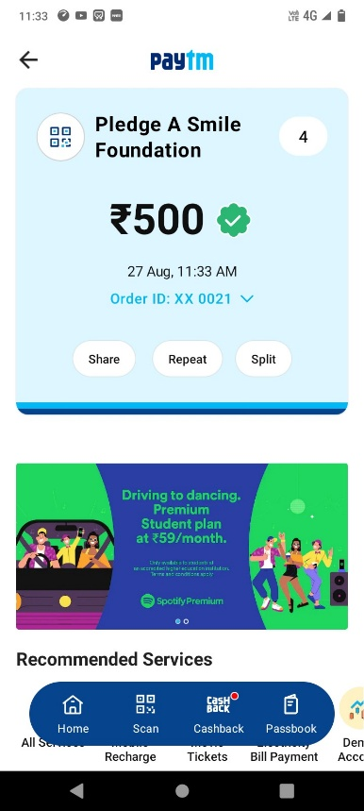

1. Name: Remlin Raj

Maild Id: [remlinraj@gmail.com](mailto:remlinraj@gmail.com)

Amount: ₹30

